Project Design Phase
Problem – Solution Fit:
Date | 27/09/2026
Project Name | Askly-AI FAQ Assistant
Team Id | SWTID-2026-9290
Maximum Marks | 2marks

Problem – Solution Fit :
The AI FAQ Assistant addresses the problem of users spending too much time searching for answers to frequently asked questions. The solution provides an AI-based system that understands user queries and provides relevant answers quickly through a simple interface.
Purpose:
- Solve the problem of finding answers to frequently asked questions quickly.
- Reduce the time and effort required to search for information.
- Provide relevant answers based on the user’s questions.
- Improve user experience through a simple and easy-to-use interface.
- Reduce repeated manual work in answering common questions.
- Understand common user queries and provide suitable solutions.
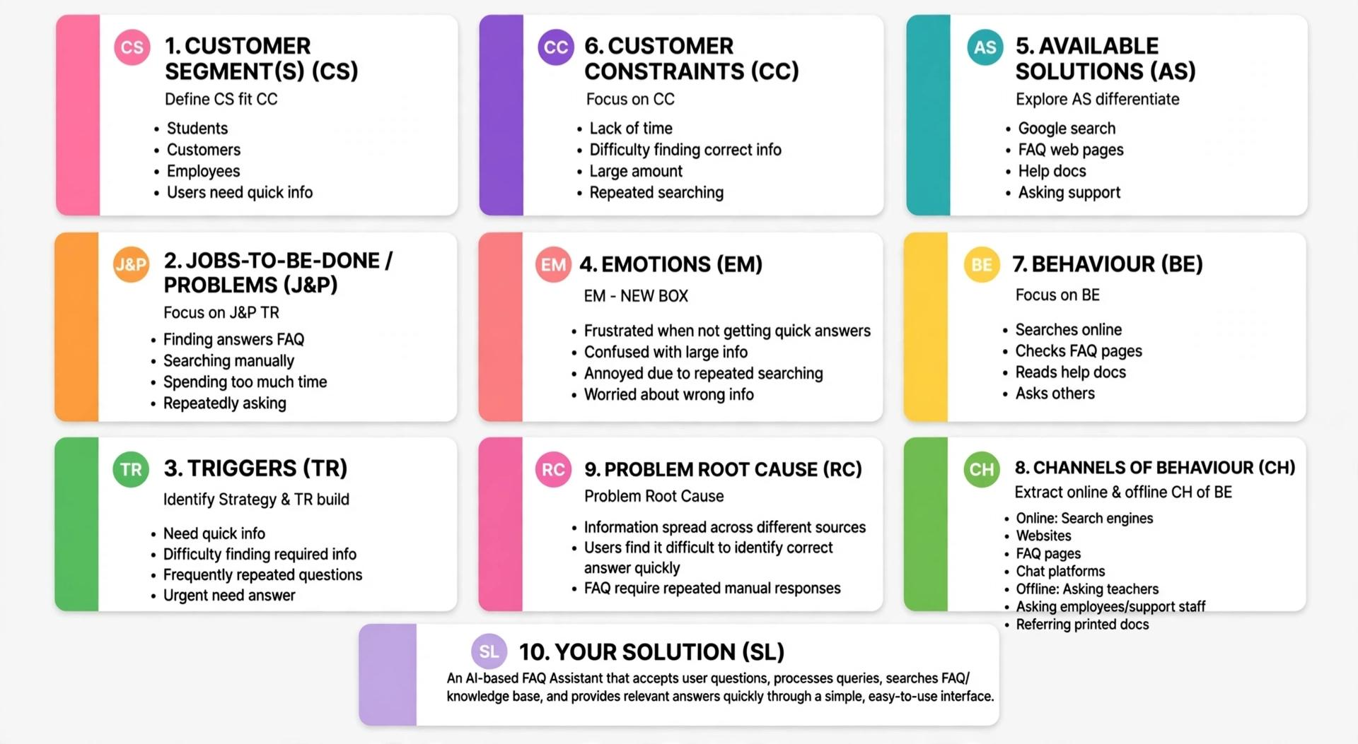
Solution:

